

NACEL Submission Importer
Alex Scott
13/04/26

Purpose
Scope
While most Case Note Review surveys are received via an online data collection page, some trusts have agreed to submit their survey data via an Excel Spreadsheet. The purpose of this tool is to create a new case code against a selected submission and import the case code survey data into the database. Each step of this process is validated and error handled.
System Logic
The tool uses 7 different API calls for various stages of the process. The stages and their respective APIs are as follows:
Retrieving Submissions
Each submitting organisation will have at least one submission recorded in the system. For the purposes of importing data, it is essential that the correct Submission_ID is selected.
After the user enters the Project_ID (which will typically remain constant for this NACEL tool) and selects the submitting organisation, an API call is used to retrieve all submissions associated with that organisation. The retrieved submissions are then displayed in a drop-down menu, showing both the Submission_ID and Submission_Name, allowing the user to select the correct submission before proceeding.
Importing File Data
Once a submission has been selected, the user can import survey data rows from the submitted Excel template file into the tool.
These template files are designed to be cumulative, meaning previously submitted rows may still be present. Therefore, the tool must assist the user in identifying which rows are likely to have already been imported.
It is important to note that the tool cannot guarantee the integrity of previously submitted rows. Organisation staff may have edited or rearranged existing data, which could cause rows to appear either unimported or previously imported when this may not actually be the case. As such, manual verification by the user is still required.
To support the user in determining the status of each survey row, the following checks are performed.
When rows from the template file are pasted into the tool, an API call retrieves all case codes associated with the selected submission. Each case code is then examined to identify the presence of its unique reference number, which corresponds to the reference number included on each row of the template file.
Where a matching reference number is found, the submitted responses are compared against the values currently stored in the database. If rows have been rearranged or modified, the reference numbers and associated responses may no longer match, helping to highlight potential discrepancies.
In addition, survey row responses are validated against a master survey document to confirm that the response text matches the language defined for the survey question. This validation ensures that, during the import process, the correct list item ID can be determined for each response.
Importing Survey Data to the Database
Once all data validation checks have been completed, the user can import the selected survey rows into the database. A toggle control allows the user to choose whether the data should be imported into the test or live database environment, depending on their requirements.
When the Import Data to Database button is clicked, each row is processed sequentially. The system completes the full import process for one row before moving on to the next. The processing steps for each row are as follows:
- Each survey response is converted from its text value into the corresponding list item ID.
- An array is created containing two columns: the question ID and the associated list item ID.
- An API call retrieves and creates the next available case code. At the same time, a string containing the row’s unique reference number is inserted into the case code note field in the case code database record.
- The system verifies the successful creation of the case code via an API call.
- The response list item IDs are submitted to the database via API.
- The case code status is updated to “Completed.”
Error handling is implemented at every stage of the process. Each step will only proceed if the previous step completes successfully. If a failure occurs, an error message is generated to indicate the stage at which the process failed, allowing the user to identify and address the issue.

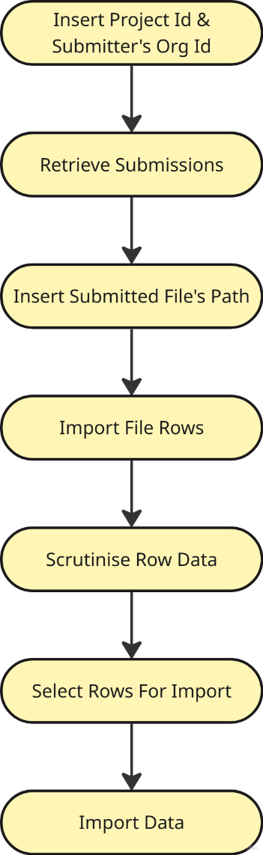
Overall Process Map

Instructions
Preparation
- Confirm that the correct Project ID is entered in the Project ID box.
- Select the submitting organisation from the drop-down menu and click the button alongside it to retrieve the list of available submissions. From the populated drop-down list, select the appropriate submission.
- Paste the file path of the received template into the Submission File Path box.
As with most VBA tools, it is generally best to store the file on your C drive. Any standard file path structure should work, but the path must not be a SharePoint URL.
- Click the button next to the Submission File Path box to import the survey rows into the tool.
- Review the imported responses and check for any orange cells.
At this stage, orange indicates that the text value of the response does not match the values listed in the Drop Downs worksheet. To correct this, copy the appropriate response value from the Drop Downs sheet and paste it into the corresponding response cell on the Home sheet.
- Review the rows to determine which responses appear to have already been imported to the database and which have not.
- For rows where the tool has identified an existing case code, ensure that all response cells are green, indicating that the values match what is currently stored in the database. Any orange cells should be investigated further.
- Confirm that rows you wish to import have “Yes” in Column F, and rows you do not wish to import have “No.”
- Click Import Data to Database and bask in the light of your glory, knowing that, on this day, the VBA gods have smiled upon you.

